## Optical Odometry Prototype Research

By: Kenneth Laws

Date: 11/09/2017

Capture Hardware: Odometer HW

## Prototype Test Plan

*Overview:*

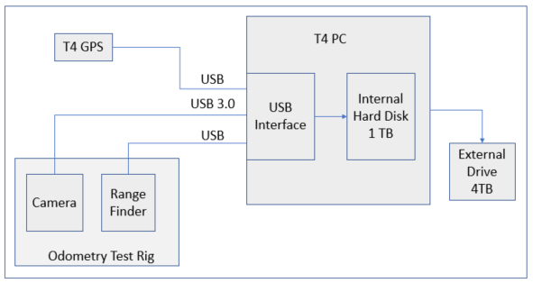

System Block Diagram

For prototype experiments, we plan to deploy a vehicle with test rig and T4 standard equipment connected. If possible, it would be good to shut down all unnecessary data collection during test trials.

* Prior to tests, the vehicle will travel to test location where there is optimal GPS coverage and opportunity to operate over a wide range of test speeds, road conditions and light conditions.
* During tests, data will be read in and stored directly to disk at the highest speed possible. It is likely that we will be limited to < 400 MB/sec which will restrict some modes of operation of the high-performance cameras, unless we implement a high speed PCIe M.2 format SSD drive.
* Collect data over part low speed track with turns and corners, part high speed (highway) for approximately 10 min (106,200 to 153,000 sequential images).

*Test Plan:*

1. Construct a test jig to mount camera and rangefinder from a trailer hitch receiver to be mounted on a vehicle equipped with a T4 rig computer and highly accurate GPS. Test jig camera and rangefinder mount should be moveable to facilitate operation over a range of height above ground from 20 cm to 36 cm and should provide as much vibration isolation as possible. If the same mount could be designed to accommodate ground sensing radar experiments, this would be a plus.
2. Collect data over 6 runs, approximately 15 minutes each. Use the highest end camera from the candidates, 1/1.2” sensor, GS3-U3-23S6M-C, at highest frame rate possible with 3 lenses of different focal length. Before beginning each run, take a small series of training set data that include a tape measure or other measurement standard visible at the edge of the image frame. At the start of each run, hold vehicle position stable to record GPS time and position for the start of the run. Camera image times should be sequentially numbered to indicate the elapsed time since the start of the series. After each run, transfer data to an external drive. As time allows, the runs listed below can be done two or three times to generate redundant data for analysis.
   1. optimize resolution, 8 mm lens at 20 cm height
   2. optimize resolution, 12 mm lens at 25 cm height
   3. optimize resolution, 16 mm lens at 33 cm height
3. Process data to retrieve position vs time
   1. Write matlab scripts to evaluate the training set data and determine the image resolution (pixels/meter)
   2. Write a matlab script to read all image files sequentially from a selected folder and process sequential images for change in position.
   3. Write a matlab script to load in rangefinder data and match in time to camera image data
   4. Write a matlab script to calibrate For each change in position, record the elapsed time since the start of the series (obtained for the image meta data)
   5. Write a matlab script to read a GPS time series file and extract data that covers the span of the run.
   6. Write a matlab script to matchup the image-based and GPS position data series and compile error statistics
   7. Write a matlab script to perform real-time calibration of image resolution based on rangefinder data
   8. Repeat analysis for other data series
   9. Write a matlab script to average image data pixels to effectively produce lower resolution data sets. Use this for evaluating effect of image resolution on odometer performance.
4. Analysis
   1. Determine optimal processing parameters
   2. From the trial runs, determine the most important data collection parameters and limitations
   3. Evaluate the observed limitations on roadway surface and lighting conditions
   4. Evaluate performance of real time calibration of image resolution based on range finder data
   5. Estimate uncertainty as a function of time for the given set of prototype experiment conditions
   6. Evaluate justification for further experimentation/development

*Required Components:*

|  |  |  |  |  |
| --- | --- | --- | --- | --- |
|  |  |  |  | Price |
| Camera | Flir | GS3-U3-23S6M-C |  |  |
| Alt Camera | Basler | ACA1920-155UM |  | 887 |
| Lens 1 | Tamron or eqiv. | M112FM08, 8 mm, 1/1.2 |  | 289 |
| Lens 2 | Tamron or eqiv. | M112FM12, 12 mm, 1/1.2 |  | 248 |
| Lens 3 | Tamron or eqiv. | M112FM16 , 16 mm, 1/1.2 |  | 248 |
| rangefinder | Maxbotix | LV-MaxSonar-EZ | *1 | 27.95 |
| RS232 isolator | Analog Devices | EVAL-ADM3251EEB1Z-ND |  | 42.61 |
| Internal SSD Drive | Samsung 960 PRO | 1TB PCIe NVMe - M.2 | *2 | 436 |
| External Drive |  | 4 TB |  |  |
| Test Jig Mount | In House |  | *3 |  |

1. Ultrasonic rangefinders are inexpensive. We have a couple at the office to evaluate for use in tests, otherwise there are numerous ones available for ~ $40
2. Internal SSD drive removes data transfer bottleneck. Other option could be to use 512 GB drive instead of 1 TB ($ 234), or limit to lower camera frame rates/resolutions/pixel depth. Option to use PRO model instead of EVO for even higher speed.
3. Have discussed with Christian and he has a design idea utilizing bumper mounted solutions used before.